1. After Installing XAMPP, go to **C:\xampp** and open 
2. Run the local server: 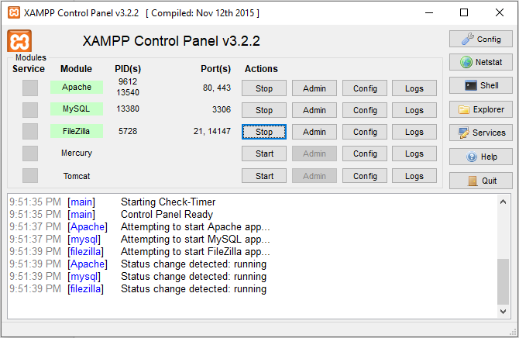
3. Copy the main files to a folder ‘ecomm’ under ‘C:\xampp\htdocs’.
4. Open ‘<http://localhost/phpmyadmin>’ from browser. Create a database ‘ecomm_db’ and import the sql file from database folder
5. After configuring, open localhost/ecomm from your browser.